Homework P6
A. Concepts (10 points)
Write a two or three paragraph summary of the concepts presented.
Include an overview of hill climbing and simulated annealing.
Define the terms local and global minima and maxima in your overview.
For the first 40 minutes of the video, we get an overview of what optimization is, referring as to choosing the best option from a set of options. We also get introduced to local search, which refers to search algorithms that maintain a single node and search by moving to a neighbor node. In the video, we can see two types of search methods: hill climbing and simulated annealing.
Hill climbing is an algorithm that looks for the maximum/minimum value starting from an initial state and moving to its neighbors to find the next better value.
Simulated Annealing looks for the global maximum or minimum by making random moves in the dataset, gradually reducing the probability of accepting moves as they converge to the global maximum or minimum. The goal of this algorithm is to find the value without getting stuck in a value.
Local max/min occur when neighboring values are max or min, but the whole dataset is not at its max/min.
Global max/min is the value that represents the entire dataset, whether it is the maximum or minimum.
Using the code provided optimization.py to answer the following questions. The code simulates a scenario where there are five cities (shown with C) and two cell towers. One of the cell towers (7,14) has a fixed location. The second cell tower should be placed at a location that minimizes the distance to each city.

B1. If position (1,5) were randomly chosen as a starting point for the 2nd tower, what is the next position that would be chosen if a hill climbing approach was used? Describe how you arrived at your answer (3 or 4 sentences).
The next position that hill climbing will choose is (2,5) which is a total cost of 41. This is because hill climbing uses the initial state and then looks for the neighbors, this is up/down/right/left and then from those neighbors it chooses the best option, in this case the lowest value, which is 41, after that we repeat the process until we don’t find any better values.

Assuming you continue with a hill climbing approach, would the global minimum be found (why/why not) (2 or 3 sentences)?

No, it will find the local minimum, because the Hill Climbing approach will get stuck. We do not know whether it is the global maximum because we do not know the other numbers. We just saw a couple of numbers, and we cannot be sure if that one is the global minimum.

B2. If position (4,25) were randomly chosen as a starting point for the 2nd tower, what is the next position that would be chosen if a hill climbing approach was used? Describe how you arrived at your answer (3 or 4 sentences). Assuming you continue with a hill climbing approach, would the global minimum be found (why/why not) (2 or 3 sentences)?
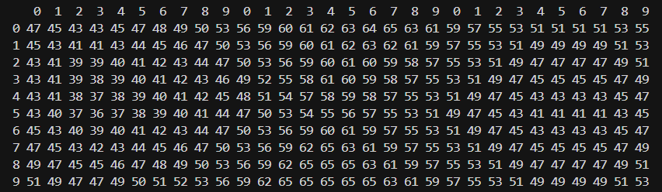

If we start at (4,25), the total cost will be 43. If we use the Hill Climbing approach, the next value will be (5,25) with a total cost of 41. I arrive at this answer by using the pseudocode in the Harvard class. From (4,25), we grab the neighbors 45, 41, 43, and choose the minimum cost, which is 41, ending with the position (4,25). We cannot reach the global minimum because there are many repeated values, this won’t change the current value and we will not get out of that state getting to a point where the code is just storing that local minimum.

B3. Describe how simulated annealing may help to ensure a global minimum is found in this scenario (3 or 4 sentences) Use the code provided optimization_annealing.py to clarify your understanding.
Simulated annealing can help us reach the global minimum by accepting worse moves. By looking at neighbor nodes and selecting the best option, we might finish close to the global minimum. This algorithm does not ensure it, but it gives us a chance to finish with a close number.

C. Other Problems (20 points) Research other problems (or scenarios) that could use hill climbing and simulated annealing for optimization. Describe each scenario in two or three paragraphs (4 to 6 paragraphs total).
The first problem I found was the logistic route. Different companies like Amazon, FedEx, and USPS need to find the best possible route for their trucks to go from the main city to multiple cities and back, while also optimizing the route to save on gas, tolls, time, and delivery time.
- Using Hill Climbing, we can evaluate a switch of cities to see if it reduces the total distance and cost. At the same time, the algorithm can get stuck in a local route that may seem good but is not the shortest or best option overall.
- Using the Annealing algorithm, we will start with the worst route and gradually change it to the best or the closest route for the delivery.

The second problem is VLSI Circuit Design, which involves the placement of components on a chip and the routing of connections. The idea is to reduce the wire length, reduce signal delay, and avoid congestion.
- Hill Climbing can attempt to reduce the wire length by swapping the positions between adjacent components. If the length is reduced, the swap stands; however, if it gets stuck during the change, it is done.
- With annealing, we can start with the longest length we have and, by looking at the best path, reduce the length until we reach the nearest global minimum.

